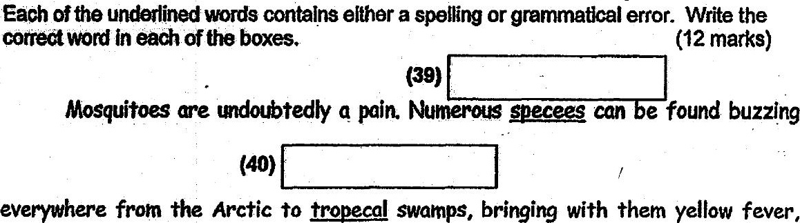

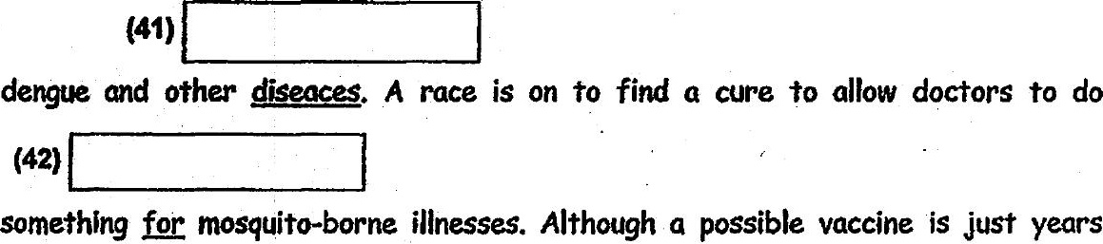

away, something needs to be done about the mosquitoes which tranaaytted viruses so

as to minimise human suffering. However, we need to consider if there could be

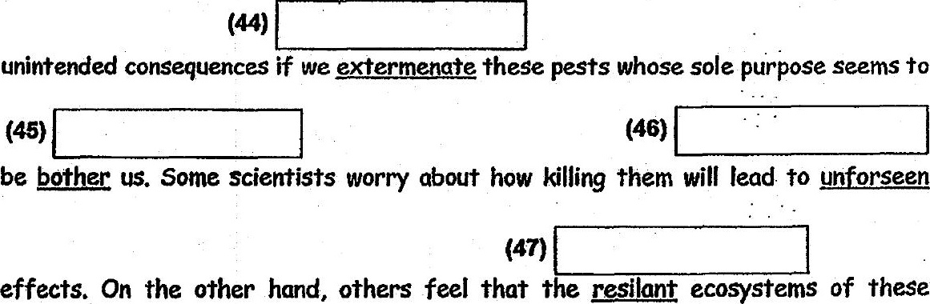

insects are not only functional but hardy than we think. In the past, the world might

have come close to killed fhese bugs by spraying insecticide wherever the mosquitoes

lives, Alas, due to the health risks of these insecticides, their use is being curbed.  
Adapted from www.sclence.gov